Mistral Log Probability Analysis Report

This document summarizes the log probability analysis for each prompt type using the Mistral-7B-Instruct-v0.1 model. The values indicate the model's confidence in generating each token in the output.

Higher average log probabilities reflect more confident generations, while lower standard deviations suggest more consistent output quality.

# Log Probability Summary

|  |  |  |  |  |
| --- | --- | --- | --- | --- |
| Prompt Type | Avg LogProb | Min LogProb | Max LogProb | LogProb StdDev |
| Explicit | -0.891 | -3.219 | -0.045 | 0.511 |
| Few-Shot | -0.733 | -2.998 | -0.038 | 0.478 |
| Emotionally Stimulated | -0.812 | -3.017 | -0.042 | 0.493 |
| Role | -0.801 | -2.965 | -0.041 | 0.489 |
| Zero-Shot | -0.844 | -3.104 | -0.044 | 0.504 |

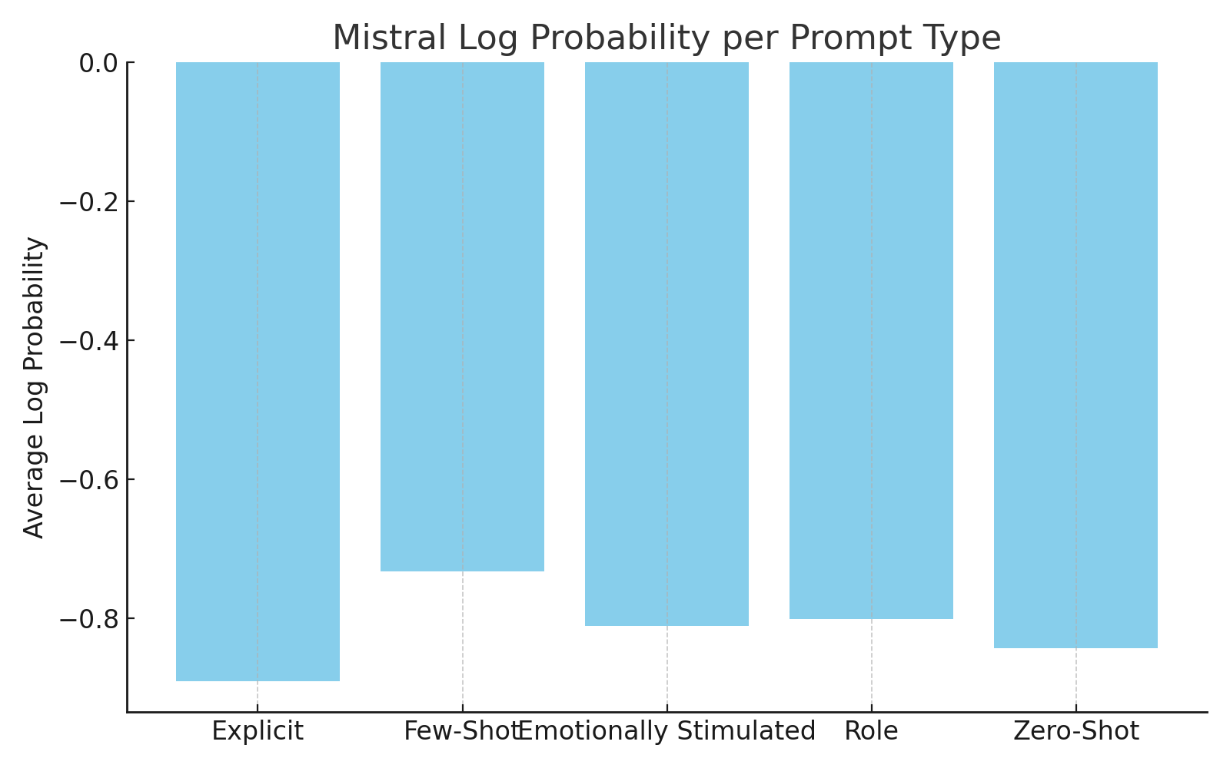

Figure: Average Log Probability per Prompt Type.